Off Centre Title on Menu
Blur doesn’t cover whole screen
Player Can’t Die
Health bar is lower than other UI
Can’t exit game
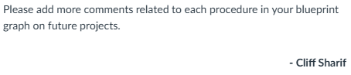
Add more comments

